**PERSONAL JOURNAL**

* 11/20 – Larz Pal-ing gave a task to do for each member in the group. I am assigned to create SVGs about the topic given.

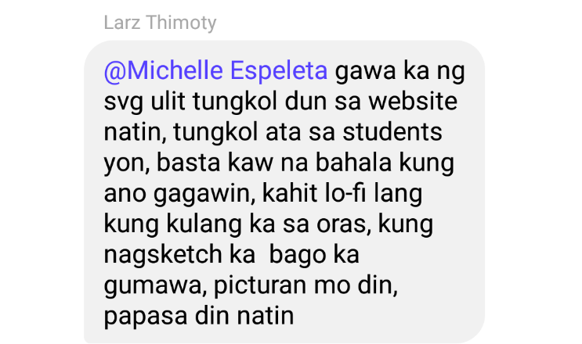

* 11/21 – I created a draft sketch for our Log-In Page, Student Home Page, and Admin Home Page SVG’s. *\*refer to team progress for the sketches*

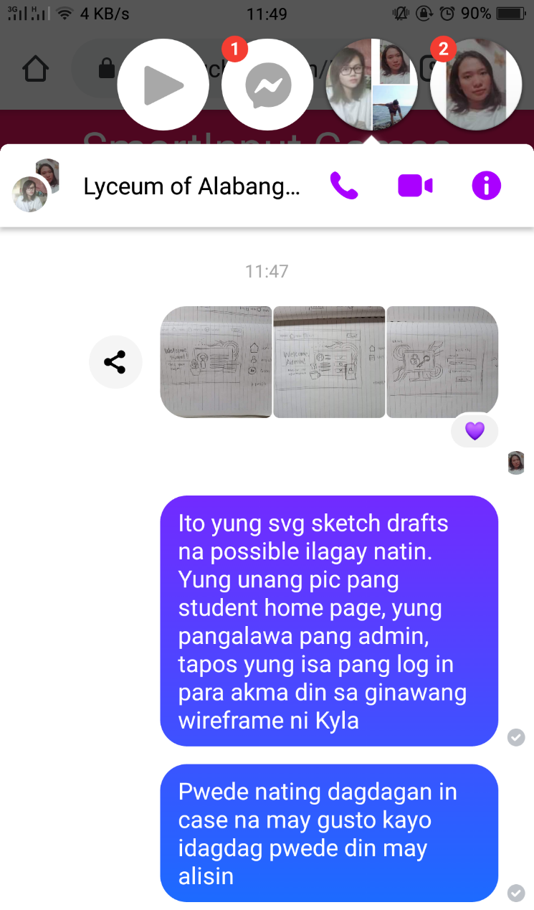

* 11/22 – I created SVG’s for our Log-In Page and Student Homepage. We use monday.com to check and monitor our progress.

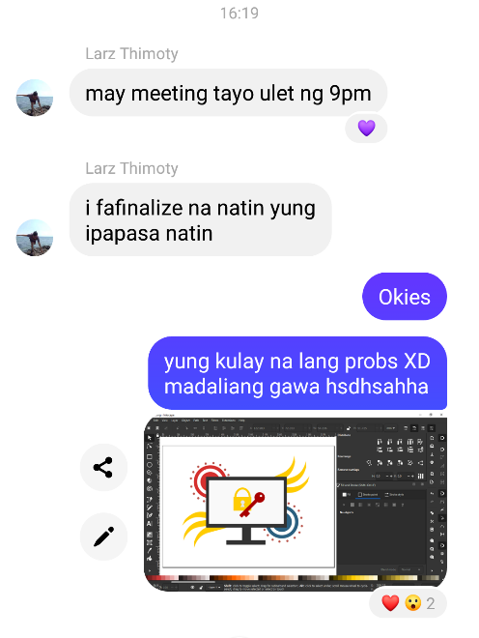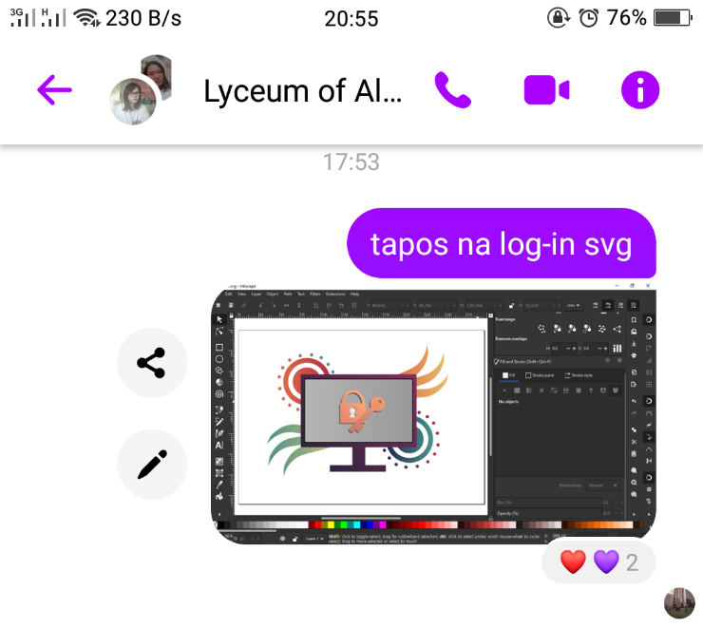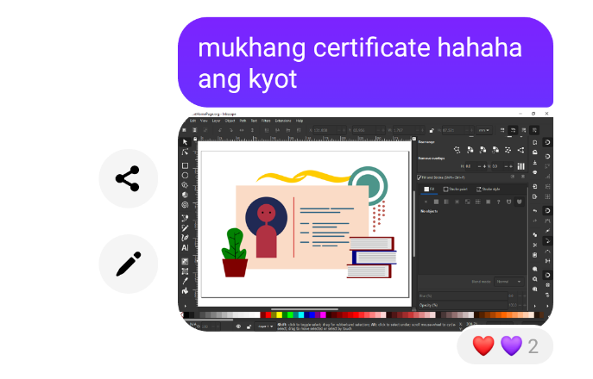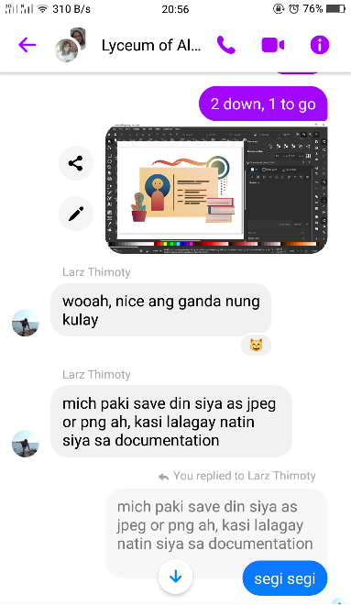

* 11/23 – I finally finished the Admin Homepage. Next is the High Fidelty.

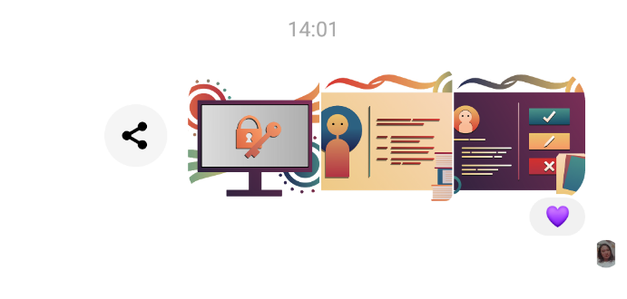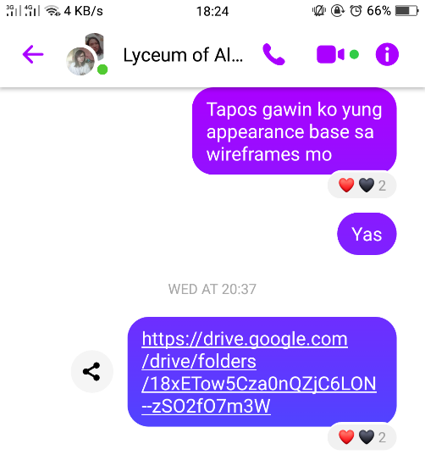

* 11/26 – I created a draft Hi-Fi for our Login Page and showed to the group. Larz gave his opinion about the design I made and did a few more versions.

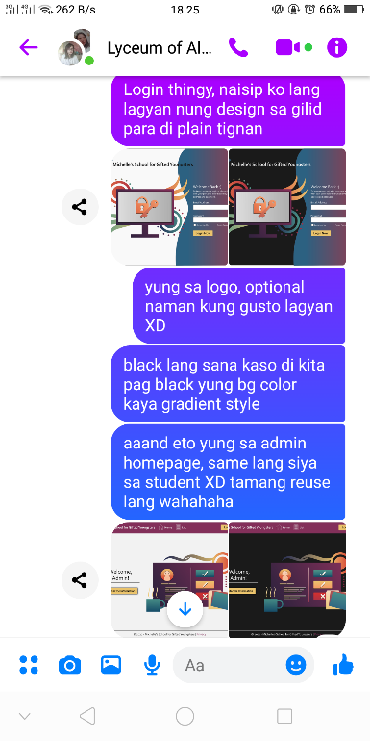 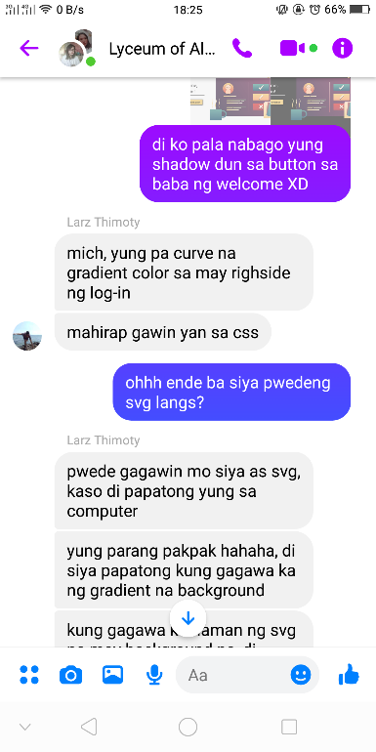 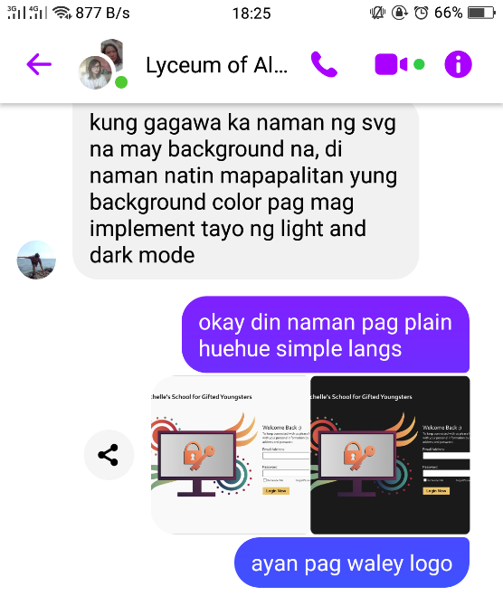

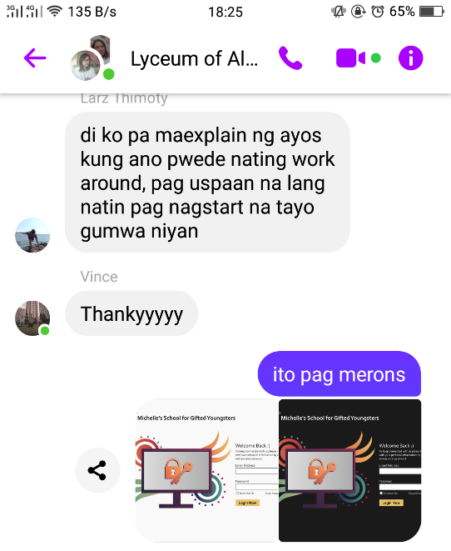 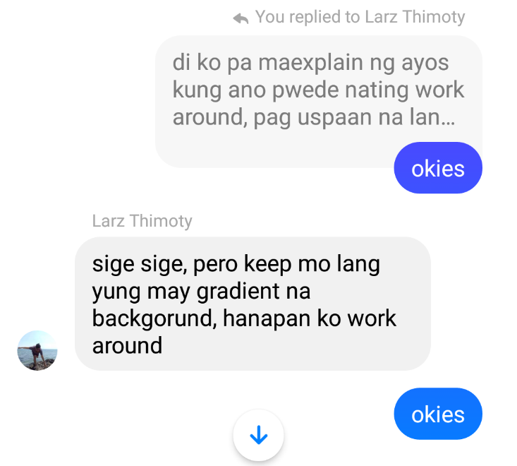

* 11/27 – I finished the Hi-Fi for our Login Page, Forgot Password Page, Reset Password Page, Admin Homepage, and Student Homepage. Only eight (8) High Fidelity left to do based on the wireframes Kyla Samson created.

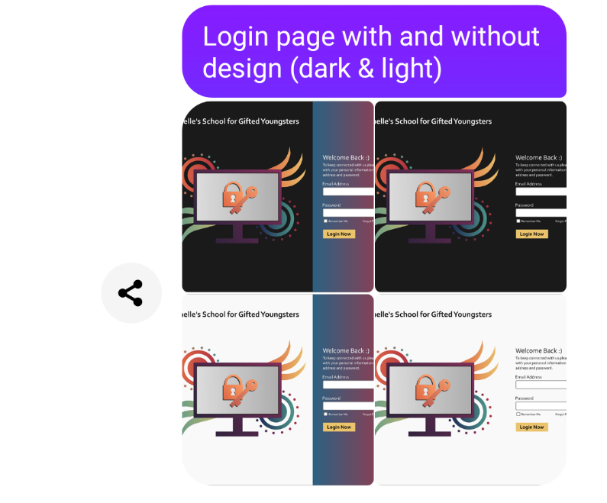

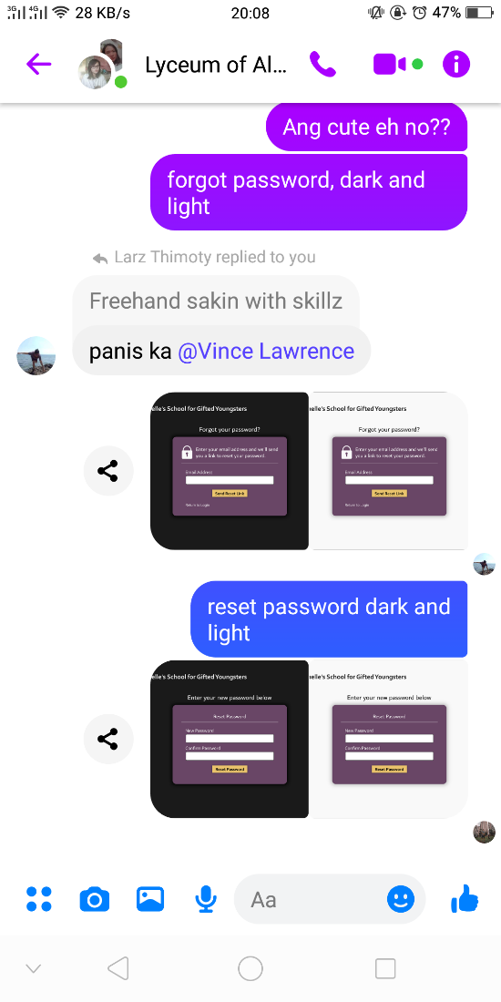 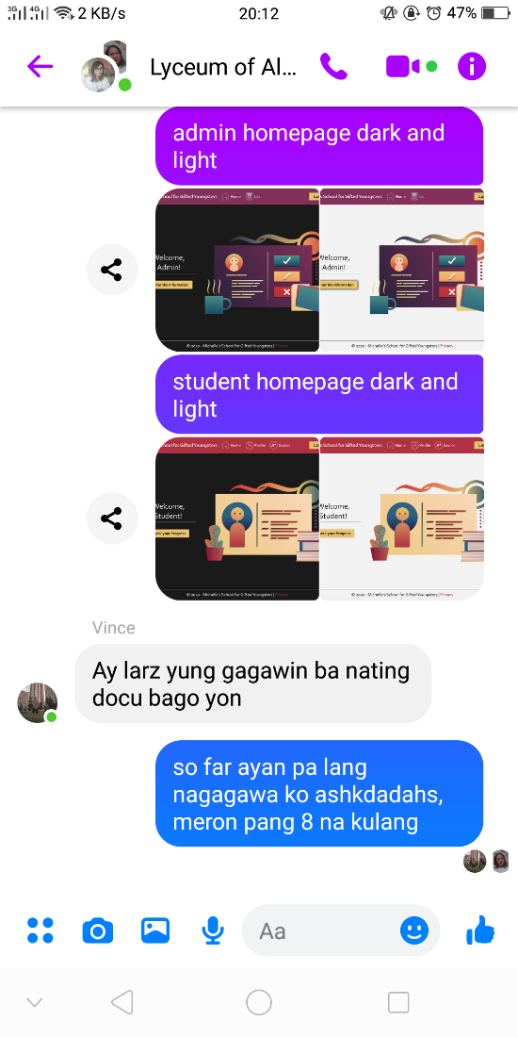

* 11/29 – I finished the high fidelity design for the Student Profile Page and Student Grades Page. There are four (4) more left to do.

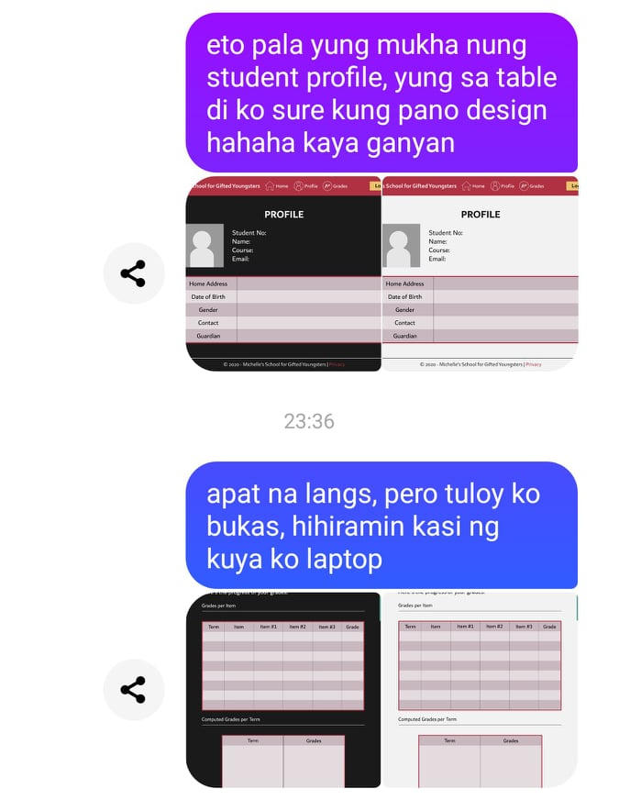

* 11/30 – Larz asked me to create an icon for dark mode and light mode options to be used in our nav bar.

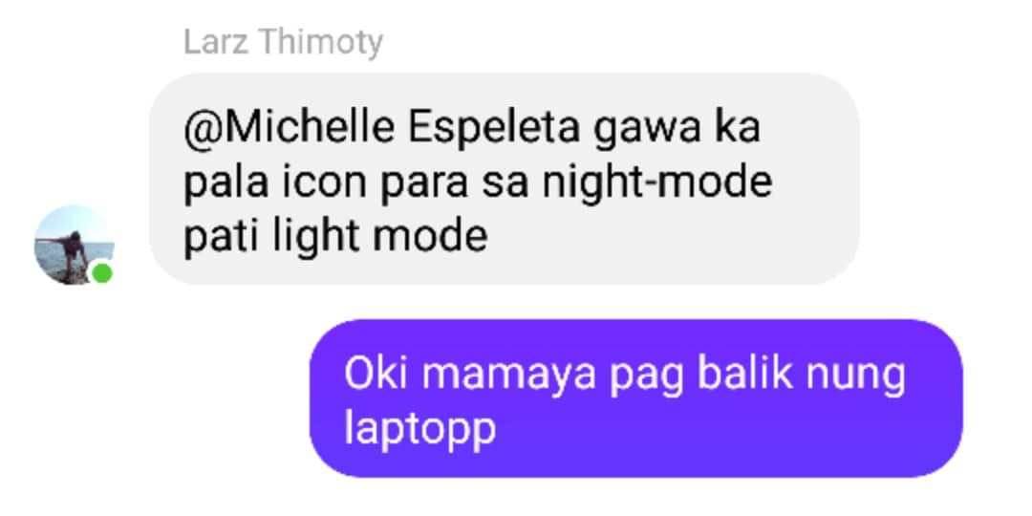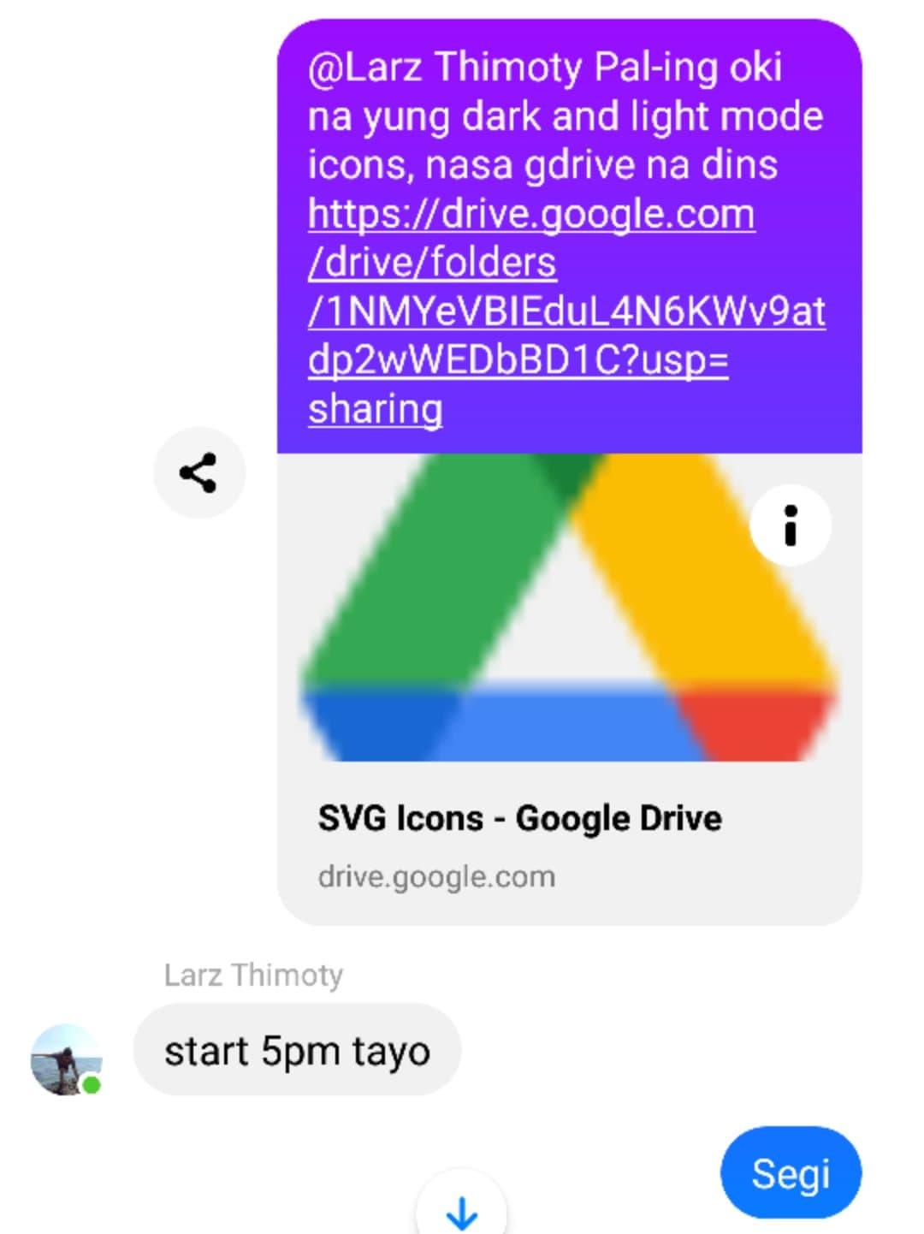

* 12/01 – I finished all the high fidelity designs for our website. Uploaded it on google drive for copy.